**COSC 4351**

**Name: Hugh Hoang**

600 points

**ERD to Relational Modeling – WHAT to HOW Practice**

Perform **ERD** Modeling then **Relational** Modeling for the Requirements below.

You must use Microsoft Word Case Tool.

**Insurance Company Application Requirements:**

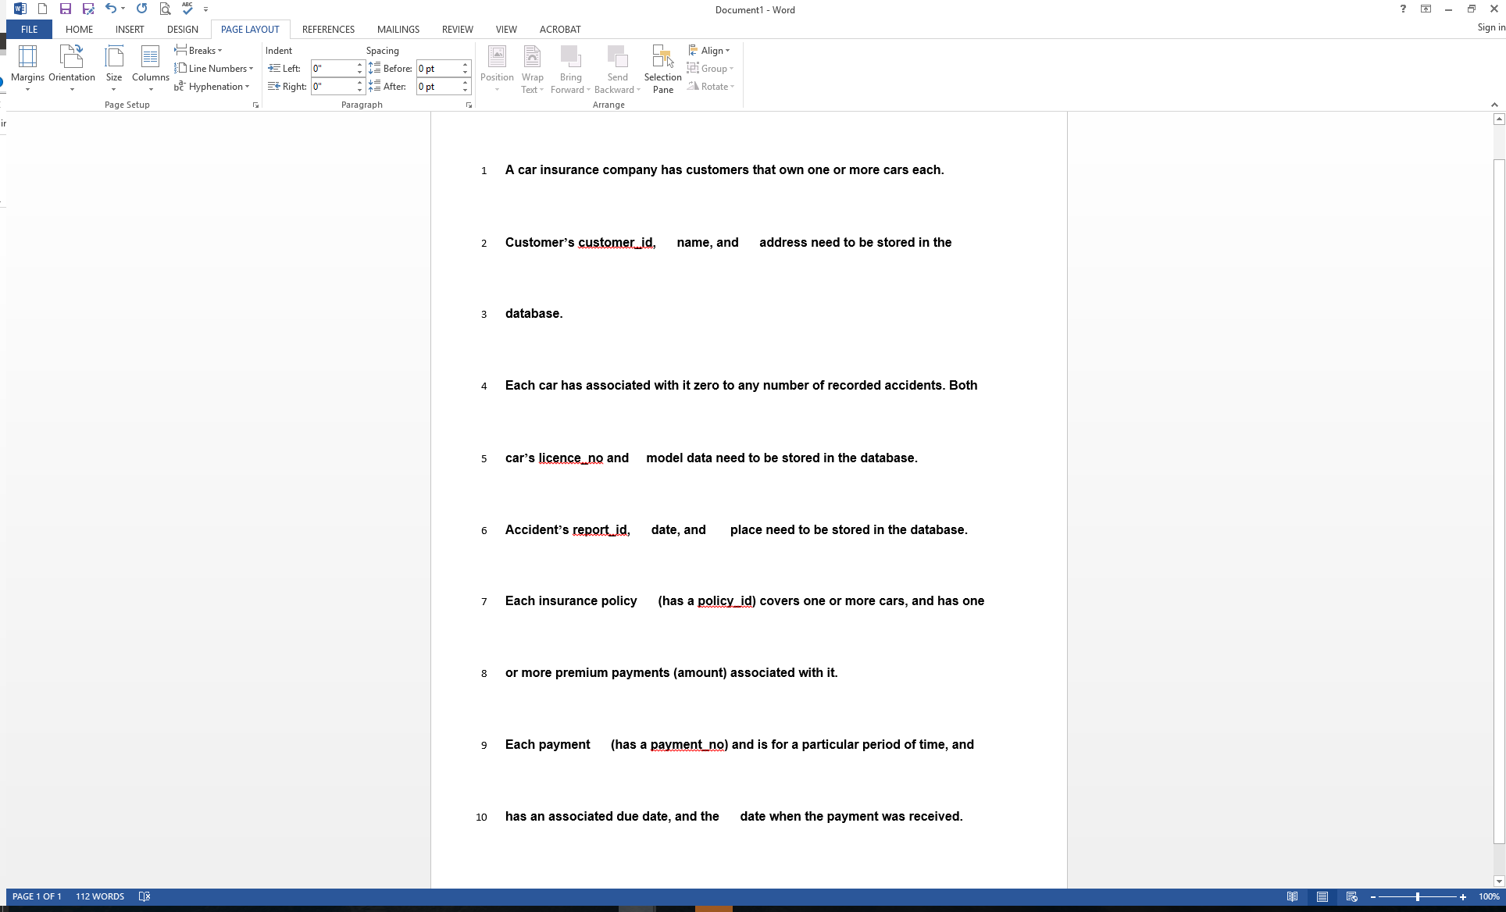

**Perform ERD Modeling**

1. (300 points)

**Entity 1: Customer**

**Attribute 1:customer_id**

**Attribute 2: name**

**Attribute 3: address**

**Entity 2: Car**

**Attribute 1: accidents**

**Attribute 2: licence_no**

**Attribute 3: model_data**

**Entity 3: Accident**

**Attribute 1: report_id**

**Attribute 2: date**

**Attribute 3: place**

**Entity 4: insurance**

**Attribute 1: policy_id**

**Attribute 2: amount**

**Entity 5: payment**

**Attribute 1: payment_no**

**Attribute 2: period**

**Attribute 3: due_date**

**Attribute 4: received**

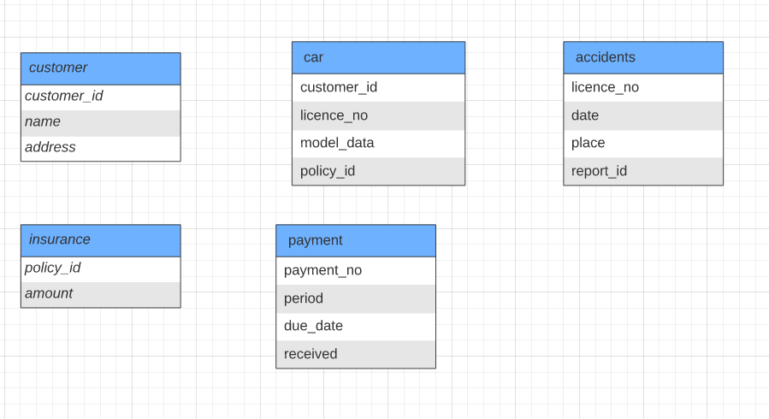

**Perform Relational Modeling**

2. (300 points)

**(Must copy the ERD produced in 1. here, please do not annotate the ERD in 1.)**

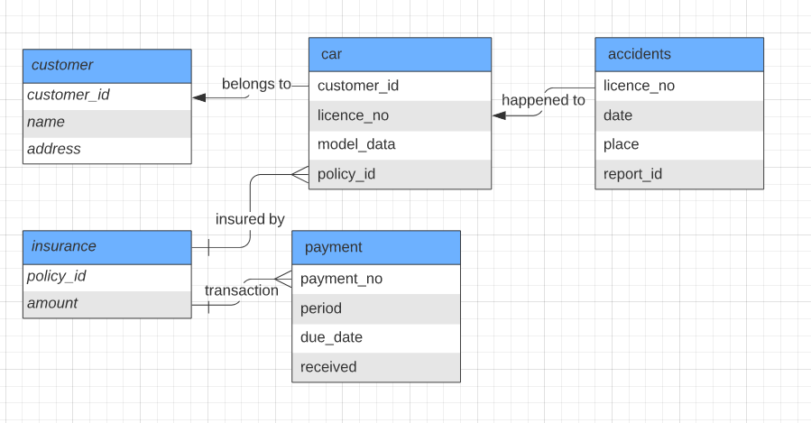

**NOTES:**

**You must attach the completed ERD and Relational Modeling in BB against the assignment.**